Dalton Haselgrove

ARTH-339W

Dr. Susik

March 11, 2017

Barnett Newman: Man, Heroic and Conflicted?

My own thesis, based on the thesis provided by Leja in his article titled *Barnett Newman’s Solo Tango* and supporting information from Sanford Schwartz and his article titled *Clement Greenberg: The Critic and His Artists*, is best summed up in a question and answer format. I will preface this essay with the question and I will aim to answer it throughout using formal analyses of a Newman piece as well as a Pollock in combination with these two articles. The question posed for you, the reader, to keep in mind throughout this essay: Are the masculinity and bodily representations such as the “zips” in Newman’s paintings and the ejaculatory nature of a Pollock, problematic in the eyes of Clement Greenberg and the eyes of the public for the abstract expressionist movement and did this play a part in the delayed rise to popularity for Barnett Newman and his works in the minimalist performance art era rather than the abstract expressionist era for which he sought? Now, with this in mind, I will provide personal insight on the Leja article on Newman and pull apart his thesis for use with my own devices.

In the Leja article I want to focus on the discussion on the gendering of the works and how this effects public perception of the works and also the conflicts that arise within the pieces. There are different forms of conflict that Leja expresses in in his article. He mentions the conflict between the male and the female in two extremes. One where the male is the rational one providing order and control and the female represented by irrationality and disorder and on the other side, maleness represented by violence and potency versus the female, and the female as a form of containment and restraint. He also mentions “conflict writ large, conflict within the self, conflict structured by gendered opposition… [as] a sort of violent, intersubjective, heterosexual tango.”(Leja, 568) I will be exploring these conflicts within a pair of example works and use this to determine whether or not this sort of conflict is even present in those works and what the effect is of the proverbial tango is on the public’s reception of the works. The first piece we will look at is one by Barnett Newman titled *Vir Heroicus Submlimis.* I will begin with a formal analysis of the piece and use that to formulate a conjecture about the piece in relation to gender conflicts and a conflict within Newman’s self.

In Newman’s piece *Vir Heroicus Submlimis*, there is a very large amount of a deep red color. With the exception of several “zips”, as they are so often referred to by art historians, the piece is monochromatic. There isn’t much to this piece at first but upon closer inspection, the “figures” in this piece appear to be the most important and they are what will be focused on in this essay for they provide a kind of gendered conflict that isn’t one of the standard “heterosexual tango.” More on this later. The vertical lines in *Vir Heroicus Sublimis* are different colors. Two of the lines are of a similar almost orange color and appear very hazy amongst all the red. This gives these lines a vague impression of depth. The monochrome red goes from being just a flat plane to being more of a haze with some of these vertical lines appearing at different depths within the red as the monochrome color seems to swirl in front and behind the lines giving the effect similar to that of posts in the distance on a foggy night. There are three other zips in this piece, each of differing color. The left most, non-background zip is an off-white color and has a very distinct separation from the red making it appear in the foreground in contrast to the hazy looking background lines. The next zip over to the right of the last one is a sort of median between the foreground and background lines. It is a grey color, but it appears to be painted over the red as it looks to be translucent. Finally, at the far right of the canvas, there is another, slightly more off-white zip that also seems to have a very little amount of translucence to it as though it were painted over the red. There is an heir of thought in this piece, meaning that it appears to have conscious effort behind it. Now, this in itself is problematic because as Leja states, using the word intelligent in terms of how a painting is made in this era is essentially code for a work that does not have enough spontaneity. This in itself is problematic for a number of reasons. One of which is that Newman himself expresses that he deplores “the use of this lack of spontaneity as a weapon against my work, which cannot be done except directly and spontaneously.” (Leja, 579) What he is saying here is that he does, in fact, involve a mixture of impulse and control in his work in the same way the Greenberg talks about Pollock’s works. (Leja, 579) It is also problematic because if this is the reception given by the public, it would only serve to exclude Newman from the abstract expressionists of his time. The public reception is that there is too much thought involved in its creation to be unconscious and automatic. (Leja, 568) What makes this an issue is that, this piece wants to fit in with abstract expressionists and Newman wants this as well, however the amount of consciousness, reason and intellectuality in his works indicate a certain sterility. These works of consciousness as Otis gage puts it, has been, as of late, mistrusted by us, the viewers. (Leja, 568) The dominating consciousness in his work which has also been interpreted as masculine in nature, which provides little to no conflict, at least, in a heterosexual sense where the conflict is between masculine and feminine forces. The lack of conflict goes against the chaotic push and pull that is contained within other works of abstract expressionism. (Leja, 568)

Newman doesn’t involve these previously mentioned forms of conflict, instead, he implements a form of conflict that is much different than the male/female heterosexual tango. This form of conflict is one of two seemingly opposite paradigms that are strewn together to create a complete new conflict which has roots in both virility and castration in art at the same time. The example given is Tarzan’s cry in the middle of the jungle. This cry, can be, at the same time, be interpreted as virile and portraying power, and also a cry of utter pain, frustration and impotence. The possible cause of this in the modern man would be, as Leja so eloquently states, is, “the recognition of self as autonomous unity coincides with a recognition of unbridgeable separation from the world.”(Leja, 577) This is both a negative and a positive thing where the positive is being aware of one’s own self autonomous nature and the negative being the realization that because of this, each person, including oneself, is excluded from the rest of society in some sense or another due to each person’s unique differences of self. The way this ties in with the my theory is that the dual paradigm of the impotent masculinity in conjunction with the masculinity of power creates a conflict that isn’t necessarily pertinent to the current themes in society that are being portrayed by artists at the time of the creation of Newman’s paintings. The abstract expressionist movement provides an explanation or possibly response to past events in the world such as the world wars and the holocaust. In order for painters to see the light of success in this post-war era, they had to express the changing cultural discourses in the United States. The successful abstract expressionists portrayed the self as having “irrational primitive and unconscious drives” and world events being caused by “tragic cosmic forces beyond human control.” (Leja, 569) These portrayals of the self can be seen in works such as Pollock’s *Number 1. 1950 Lavender Mist*. The portrayal of self is quite different is Newman’s works and were ahead of his time quite apparently so, due to his rise to fame nearly a decade later.

Newman, despite his denial of such a mindset, seemed to create works as though they were created by a divine being. Leja mentions how several of Newman’s titles have some relation to Genesis from the Bible and even in an interview once, Newman stated that “I don’t manipulate or play with space. I declare it. It is by my declaration, that my paintings become full. (Leja, 576) He is playing the role of God by literally separating darkness and light in his works. Power is what can be associated with this ability to create and separate. It can perhaps be seen then, that Newman could be fighting his own battles of castration anxiety by doing an extreme opposite of what it means to be impotent. The creation of art in a way that is quite biblical. He deems his art shall fill this void that is the canvas and so shall it be. When one conjures up thoughts about how the universe is created, it doesn’t matter what sort of religious background, beliefs or non-beliefs one has because this process is always imbued with power. There is even masculinity in the creation of this piece.

Jackson Pollock. Essentially Greenberg’s favorite metaphorical child. Pollock’s works exemplified what Greenberg had been seeking in modern art for the most part with medium specificity, truth to materials and a creation with pure automatism. (Schwartz, 541) The piece titled *Number 1. 1950 Lavender Mist,* is what I take aim at here to shed some light on what it is about Pollock that allows him to rise to fame in the abstract expressionist world and what causes Newman to miss his mark. *Lavender Mist,* as I will refer to it as, falls directly in line with Pollock’s very chaotic yet controlled themes in his paintings. Themes in this case being the interaction between colors with each other and the viewer. This piece is oil, enamel and aluminum on canvas that was painted on the floor by spattering, pouring and tossing of paint about the surface. The work is covered in off whites, teals, blacks, whites and some tans and greys. Each color is pattered about the canvas in a way that only paint being spattered on a horizontal canvas would do, with patterns that are indicative of Pollock’s “controlled automatism.” *Lavender Mist* covers the canvas from end to end and does not lead the viewer’s eye to any place in particular. When one looks at this piece in person, or so I have come to understand through extensive reading, it is easy to tell that the work is paint on canvas and it almost radiates with the unconscious motivations of Pollock. The fact that this piece is paint on canvas, and yet, doesn’t try to hide this fact and leaves out any form and figuration is essential to how Greenberg wanted abstract expressionism to be.

To answer my question I posed in my introduction, I believe, based on my readings and interpretations of these articles and a formal analysis of both of these works that, it isn’t just the gendering involved with these paintings that determine their popularity with a certain era. It is the gendering in tandem with the views of self and the conflict that is expressed in these works and also how well the work represents the current changes in the cultural discourses in the United States. Jackson Pollock, on one hand, creates a tension in his works that can be associated with maleness due to the ejaculatory nature and representing the male in a violent or furious way and then using smoother forms and other techniques, representing a sense of a calming femininity, perhaps within oneself or with another person, which still leads to a heterosexual tango between the conflicts. In a seemingly direct contrast to Pollock and his, what can be radically described as, a screaming homophobia of his very hetero conflicts in his works, Newman’s works are representative of a conflict of self between two parts of the self and both parts being masculine. On one hand, there is the realization of self-autonomy and this causes a gap between oneself and the rest of society. One can be seen as virile and powerful and the other, as frustration and impotence. The conflict between the potent versus the castrated male. The castrated male, in some sense could also be interpreted as female. However, based on Newman’s responses to many critics, he shares with us what seems to be a very great amount of castration anxiety which leads myself and Leja to believe that this should be an interpretation of castration as a masculine form in Newman’s works. Now, Pollock and Newman both seem to have this sort of conflict resonating within their works, however, and this is very important, Greenberg’s language defends Pollock’s works from possibly being classified as both terms of conflict being gendered masculine. (Leja, 577) Being that Greenberg is a critic and essentially provides the foundation for abstract expressionism, his role in the levels of success for Newman in the abstract expressionist movement is vital. (Schwartz, 535) If the viewers of Newman’s works conclude that the two aspects of conflict are indeed both masculine, which I certainly have come to believe, they would consider his work non-representative of current artistic representations of the human self in response to past events and could even go as far as saying that it doesn’t necessarily fall under the category of the ab-ex movement due to the conflict represented as a masculine, self vs. self, conflict. The viewer may also not come to see reflections of themselves or a form of self they can relate to due to the solitude and the dual masculine conflicts within Newman’s paintings. On top of that, Newman and similar artist’s paintings, as Schwartz describes it, “their emotions always vibrate at the highest pitch. If we are not on their wavelength, we feel nothing.” (Schwartz, 541) So, the potential for the viewer to not even feel a thing when looking at one of these works is fairly high. It’s not until the 60’s when critics and viewers develop a critique of the subjectivity of gendering conflicts in painting such that of Newman’s dual masculine cry of both power and impotency. (Leja, 579) Another aspect of ab-ex’s exclusion of Newman was his inability to, as Leja puts it, “negotiate effectively the gendered metaphors that were such a crucial structuring component in the production and reception of abstract expressionist art.” (Leja 579) I wholeheartedly agree with Leja’s thesis and do believe that this issue of gender in works is highly problematic in the art industry during this time and that viewers of such art of this era should not follow critics such as Greenberg so closely as to lose sight of a perfect representation of ab-ex art simply due to a lack a structure in which to critique the gendered nature of works such as Newman’s.

Works Cited

Leja, Michael. "Barnett Newman's Solo Tango." *Critical Inquiry* 21.3 (1995): 556-80. Web.

Newman, Barnett. *Vir Heroicus Sublimis*. 1950-51. Oil on canvas. Museum of Modern Art, New York.

Pollock, Jackson. *Number 1, 1950 (Lavender Mist)*. 1950. Oil, enamel, and aluminum on canvas. National Gallery of Art, Washington, DC.

Schwartz, Sanford. "ART CRITICISM: Clement Greenberg: The Critic and His Artists." *The American Scholar* 56.4 (1987): 535-45. *JSTOR*. Web. 11 Mar. 2017.



*Number 1, 1950 (Lavender Mist)*.

Oil, enamel, and aluminum on canvas.

Jackson Pollock

1950

National Gallery of Art, Washington, DC.

*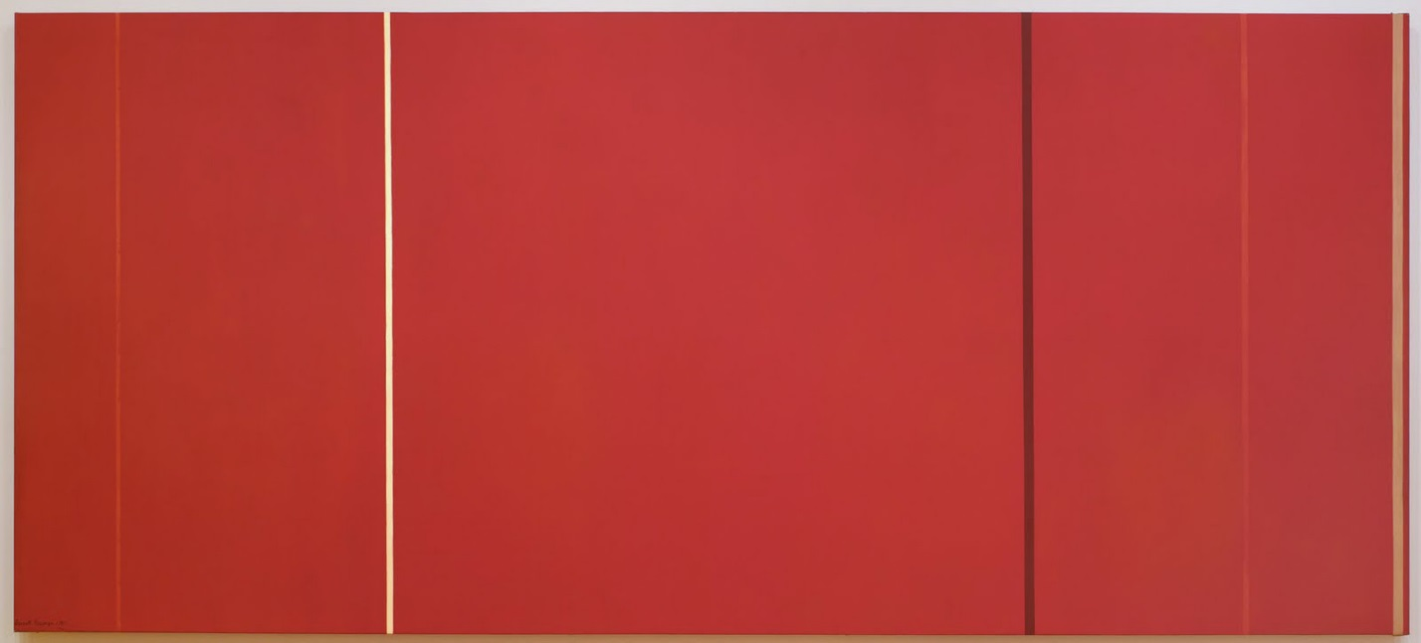*

*Vir Heroicus Sublimis*

Oil on canvas

Barnett Newman

1950-51 Museum of Modern Art, New York.